Lab 5 evidence (Virtual Machines):
Task 1:
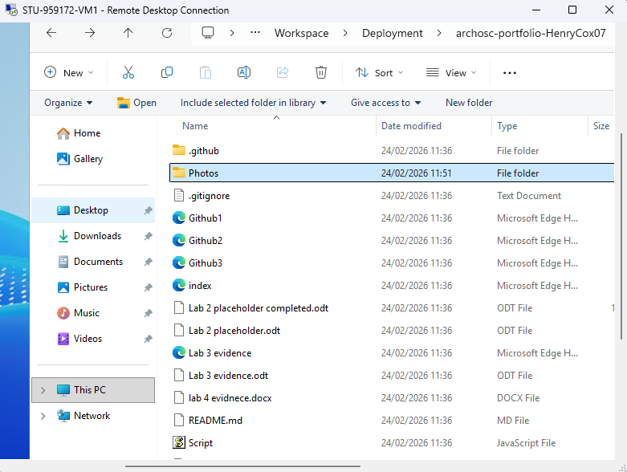
For the first task I was required to open my virtual machine and pull my repo onto it. I did this by logging into the Virtual Machine, installing git and cloning the repo on Github into the folder on the virtual machine.

Task 2:
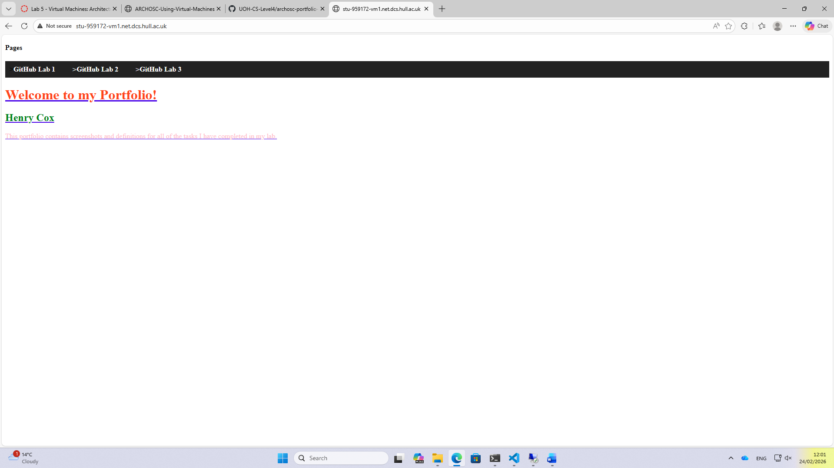
For task 2 I had to host my website from the virtual machine. The way I did this was by talking the files from my repo in the virtual machine and move the files into the wwwroot folder in the Interpub folder. Then I copied a link which brought me to my website being hosted from the virtual machine.

